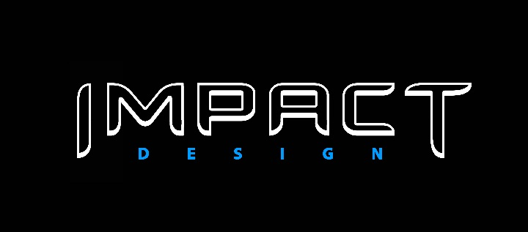

Tata Motors Defines A New Design Language for Its Passenger Vehicles

Mumbai, January 06, 2016: In keeping with its transformation journey, Tata Motors today announced its new IMPACT Design language for its upcoming passenger vehicles. With the recently unveiled ZICA as the first new product under this design language, the IMPACT Design forms the over-arching design brand which stands for ‘Immediate IMPACT at first sight. Lasting IMPACT over time.’

According to Mr. Mayank Pareek, President, Passenger Vehicle Business Unit, Tata Motors, “Today, the automakers are developing innovative technologies to cater to the needs of the new generation of customers. Design is among the key factors for car purchase decisions. Tata Motors recognizes this and presents IMPACT Design – as a key focus for the company’s passenger vehicle strategy. The new, youthful, energetic and bold character of the passenger vehicles by Tata Motors is sure to make a lasting impact on our customers and on the Indian roads.”

It is after keeping the media-saturated customer in mind that a new design language had to be created. Something that could break the clutter and reinvent the wheel every time it was applied. And thus, the IMPACT design philosophy was created.

IMPACT Design further distills the design elements that can be expected from all Tata Motors Passenger Vehicles. It will be achieved through key design elements on the Exterior and Interior.

The Exteriors design will be defined through ‘EXciting’, ‘EXpressive’ and ‘EXtraordinary’ features:
- Exciting architecture and pleasing proportions will be standard e.g. best in segment size & location of the wheels, perfectly proportioned cabin to body ratio and hood to cabin relationship
- Expressive surfaces and graphics e.g. front face framed by the Humanity Line; dynamism amplified by the Slingshot line; movement created by the Diamond Window
- Extraordinary: Details inspired by Indian Architecture

The Interior of the vehicle will be defined through ‘INviting’, ‘INtelligent’ and ‘INtouch’ features.
- Inviting interior architecture and proportions including Layered Cockpit Design; Driver Focussed layout; Outstanding Textures, Fabrics and Materials
- Intelligent Cabin Layout with clever storage spaces, surprise and delight features. All displays, commands and controls will be within easy and intuitive reach
- Intouch and connected to the world inside and outside the vehicle

According to Mr. Pratap Bose, Head, Design, Tata Motors, “You can either win or lose a potential customer within the first 20 seconds of them seeing a car. However, the customer stays with you based on the long-term experience they have with the product or service. IMPACT DESIGN is exactly about an Immediate and a Lasting Impact, Design has in our lives, and environment. From ‘INtelligent’ use of space, ‘INviting’ interiors and ConnectNext features that make you feel ‘INtouch’ with the world inside to EXpressive, EXciting’, and EXtraordinary exterior features. With the ZICA we have started this journey.”

ZICA truly embodies the IMPACT Design. It distills the fine points of auto design with styling and lines that accentuate modern India and its global citizens. With IMPACT, Tata Motors has taken one step forward in its transformation journey, reaffirming its customer centric approach which in- turn will reinforce the Company’s future in design.

About Tata Motors
Tata Motors Limited is India’s largest automobile company, with consolidated revenues of INR 2,62,796 crores (USD 42.04 billion) in 2014-15. Through subsidiaries and associate companies, Tata Motors has operations in the UK, South Korea, Thailand, South Africa and Indonesia. Among them is Jaguar Land Rover, the business comprising the two iconic British brands. It also has an industrial joint venture with Fiat in India. With over 8 million Tata vehicles plying in India, Tata Motors is the country’s market leader in commercial vehicles and among the top in passenger vehicles. Tata cars, buses and trucks are being marketed in several countries in Europe, Africa, the Middle East, South Asia, South East Asia, South America, Australia, CIS and Russia.
(www.tatamotors.com ; also follow us on Twitter: https://twitter.com/TataMotors)

Issued by:
Ms. Ashmita Pillay
Senior Manager - Corporate Communications
Tata Motors Ltd.
Email: ashmita.pillay@tatamotors.com

