Tata Motors showcases three new products at Municipalika 2015

Jaipur, December 9, 2015: Tata Motors today showcased three new fully-built vehicles, from its municipal range, at Municipalika 2015. The vehicles showcased include the Tata Ace Desilting Machine BS IV, the Tata Ace Zip_1.25 CuM Hopper Tipper BS III and the Suction (5KL)-cum-Jetting (4KL) machine on Tata LPT 1613/42 Truck BS III and BS IV. All three vehicles showcased, cater to the needs of municipal corporations and other urban local bodies in the collection and transportation of the waste, with best-in-class maneuverability and fuel-efficiency.

Municipalika 2015 is being organised in Jaipur, Rajasthan between December 09 –11, 2015

Mr. Sanjay Bhatia, Head Marketing – Institutional Sales, Tata Motors Ltd. said "We at Tata Motors are delighted to showcase three new vehicles from our municipal rage of commercial vehicles at Municipalika here in Jaipur. Through this trade fair, we are leveraging the huge opportunities in the Host State of Rajasthan, in the area of housing and urban infrastructure development. The vehicles showcased today, demonstrates their appropriateness for numerous waste-management tasks, owing to a combination of power, economy, safety and robustness, with lowest cost of ownership. With new municipal applications, we are further expanding our leadership position in the segment, backed by the company’s extensive service network.”

Salient Features of the Tata Ace Desilting Machine BS IV – Cleaning manholes/ wetwells
- Fully- built vehicle mounted desilting machine available in BS IV
- Ideal for cleaning manholes/ wetwells upto a depth of 40 feet
- Hydraulic tiltable hopper capacity 0.5 Cum
- The powerful engine churns 16 HP@3200 RPM having max torque of 3.8 mkg @ 2000 RPM
- Minimum turning circle diameter of 8.6m for easy maneuverability
- Better operating economics with 20 litres grab bucket

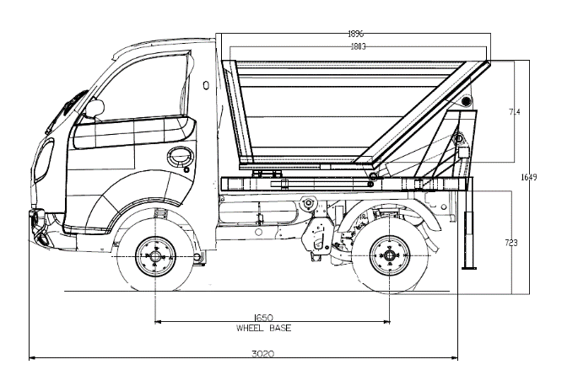
Salient Features of the Tata Ace Zip_1.25 Cu.M Hopper Tipper BS III – Movement of house hold garbage

- Fully- built tipper available in BS III
- Tipper for movement of house hold garbage, ideal especially for door-to-door garbage collection, through narrow lanes due to small size
- The powerful engine churns 11.3 HP@3000 RPM having max torque of 3.16 mkg@1600-1800 RPM
- Best-in-class turning radius - minimum turning circle diameter of 3.5m
- Panel thickness - floor – 2 mm, headboard & sides – 1.6 mm
- Better operating economics with hydraulic system
Salient Features of Suction (5KL)-cum-Jetting (4KL) machine on Tata LPT 1613/42 Truck BS III and BS IV –

- Fully- built truck available in BS III and BS IV
- Truck Mounted Mobile Unit suitable for dislodging and removing obstructions and blockages from sewer lines by a High Pressure Water Jetting System and suctioning the Sludge / slurry from sewer manholes, gully pits, septic tanks etc. by Vacuum Suction System and discharging the collected sludge by hydraulic tipping of the containers or by Blow-back Arrangement.
- Powerful engine churns 102KW(136PS)@2400RPM having max torque of 490NM@ 1400-1800RPM
- Better operating economics with 16200 kg max. permissible GVW and tank capacity of 4000 litres for fresh water and 5000 litres for sludge tank
- Best-in-class compressor cum vacuum unit - free air discharge at 600 cum / hr (approx.) and vacuum at 700 mm Hg
Tata Motors range of municipal vehicles have set new standards both technologically and aesthetically, and have rightly earned a top ranking from the municipal authorities. Tata Motors range of municipal vehicles offer fully-built solutions in the areas of solid & wet waste management (door-to-door garbage collection & transportation to garbage-dumping sites), health services, water supply, street-lighting, disaster management, and staff transportation on heavy, medium, intermediate, light and small commercial vehicle platforms. The range is designed to provide solutions for day-to-day needs, managing the supply of clean/potable water, also helping in fulfilling the basic needs of sanitation to ensure a cleaner environment and society. These vehicles come with the promise of proven performance, ease of maintenance, and better operating economics, while being environment-friendly at the same time.

Municipalika 2015 is being organised with CAPEx, a trade show focusing on Construction, Architecture, Planning and Engineering to deliberate on sustainable built environment and good urban governance.

- ENDS –
About Tata Motors
Tata Motors Limited is India’s largest automobile company, with consolidated revenues of INR 2,62,796 crores (USD 42.04 billion) in 2014-15. Through subsidiaries and associate companies, Tata Motors has operations in the UK, South Korea, Thailand, South Africa and Indonesia. Among them is Jaguar Land Rover, the business comprising the two iconic British brands. It also has an industrial joint venture with Fiat in India. With over 8 million Tata vehicles plying in India, Tata Motors is the country’s market leader in commercial vehicles and among the top in passenger vehicles. Tata cars, buses and trucks are being marketed in several countries in Europe, Africa, the Middle East, South Asia, South East Asia, South America, Australia, CIS and Russia.
(www.tatamotors.com ; also follow us on Twitter: https://twitter.com/TataMotors)

For more information, please contact:

Mr. Arthur Serrao
Corporate Communications
Tata Motors Limited
Email – arthur.serrao@tatamotors.com
Phone - +91 9619977723

Rediffusion / Edelman
Mr. Gaurav Gupta
Email – gaurav.gupta@edelman.com
Phone - +91 8898022007

